WALMART WEEKLY SALES
PERFORMANCE DASHBOARD
Project Report – Microsoft Power BI

Submitted by: Theeshmitha.S
Roll No: E25FA068
Course: B.Com (Fintech & AI), 2nd Year
Tool Used: Microsoft Power BI Desktop

1. Introduction
This project is a sales performance dashboard created in Power BI Desktop with the weekly sales records of Walmart stores. The dataset appealed to me because it combines numeric columns (sales, fuel price, CPI, unemployment, temperature) with categorical ones (store number, date, holiday flag), which allowed me to try out many different chart types in a single report.
My aim was to take a long table of raw rows and turn it into a clean, clickable report that a manager could read in a few seconds. Using the slicers on the dashboard, a viewer can narrow the data by store, date range or holiday status and see every number and chart change at once.
Charts matter in sales tracking because trends, gaps and sudden jumps are far easier to spot in a picture than in thousands of table rows. In this dashboard all the visuals are linked to each other, so picking a value in one place refreshes the rest. That is what makes it an interactive report and not just a set of separate graphs.
The first thing a reader sees is the KPI page, which summarises overall performance before any detailed analysis begins.
2. Objectives
The dashboard was designed with the following goals:
- To study the weekly sales of all 45 Walmart stores and understand the overall sales pattern.
- To present key indicators such as total sales, average weekly sales, store count and transaction count.
- To build an interactive report with slicers so the user can filter by store, date and holiday status.
- To compare holiday weeks with non-holiday weeks and see whether sales behave differently.
- To follow how sales moved over the period from 2010 to 2012.
- To check whether fuel price has any visible link with weekly sales.
- To connect all visuals together so that trends and comparisons are easy to notice.
3. Dataset Description
The data comes from an Excel file of Walmart weekly sales (Dataset 1 – Walmart Data Analysis and Forecasting). It covers 45 stores between 5 February 2010 and 26 October 2012. The columns used in the report are:
- Store – the store number, from 1 to 45.
- Date – the week for which the sales were recorded.
- Weekly_Sales – sales made by that store during the week.
- Holiday_Flag – marks whether the week contained a holiday.
- Temperature – average temperature of the region that week.
- Fuel_Price – average fuel price that week.
- CPI – the Consumer Price Index.
- Unemployment – the unemployment rate.
4. Data Preparation
Before creating any chart I cleaned the data in Power Query. The steps were:
- Import: loaded the Excel workbook into Power BI Desktop and promoted the first row to headers.
- Data types: set Store as a whole number, Date as a date and Temperature and CPI as decimal numbers.
- Text to number: Weekly_Sales and Fuel_Price arrived as text with a "$" sign, so I removed the symbol and converted Weekly_Sales to a number.
- Missing values: blank Weekly_Sales and Temperature cells were replaced with the column average, and rows with a blank Unemployment value were filtered out.
- Holiday labels: converted Holiday_Flag to text and replaced the codes with readable labels (HOLIDAY / NON-HOLIDAY) so the slicer and donut chart show words instead of 0 and 1.
After these steps the model held 6,438 rows across 45 stores (143 weeks per store).
5. DAX Measures Used
Five measures were written in DAX. Four of them drive the KPI cards and the rest of the visuals:
- total weekly sales – SUM of the Weekly_Sales column.
- AVERAGE SALES – AVERAGE of the Weekly_Sales column.
- store count – DISTINCTCOUNT of the Store column.
- TRANSACTION COUNT – COUNT of the Store column (the number of weekly records).
These are basic aggregation formulas, but they are the base for the whole dashboard and let the top row be read at a glance.
6. Visuals and Dashboard Components
Once the data was ready I added visuals one by one, choosing each chart type according to the question I wanted answered. All visuals are connected to the same slicers and measures, so they respond together to any filter.
- KPI Cards
I started with four KPI cards for a quick snapshot of the dataset: Total Sales (total weekly sales measure), Total Store (store count), Transaction Count and Average Sales. Keeping each figure in its own card lets the reader see the headline numbers without opening any detailed chart.
Store Summary Table
A table with Store as the row field and Total Sales, Average Sales and Transaction Count as values was added next. The cards give only one overall figure, whereas this table lets me compare every store side by side.
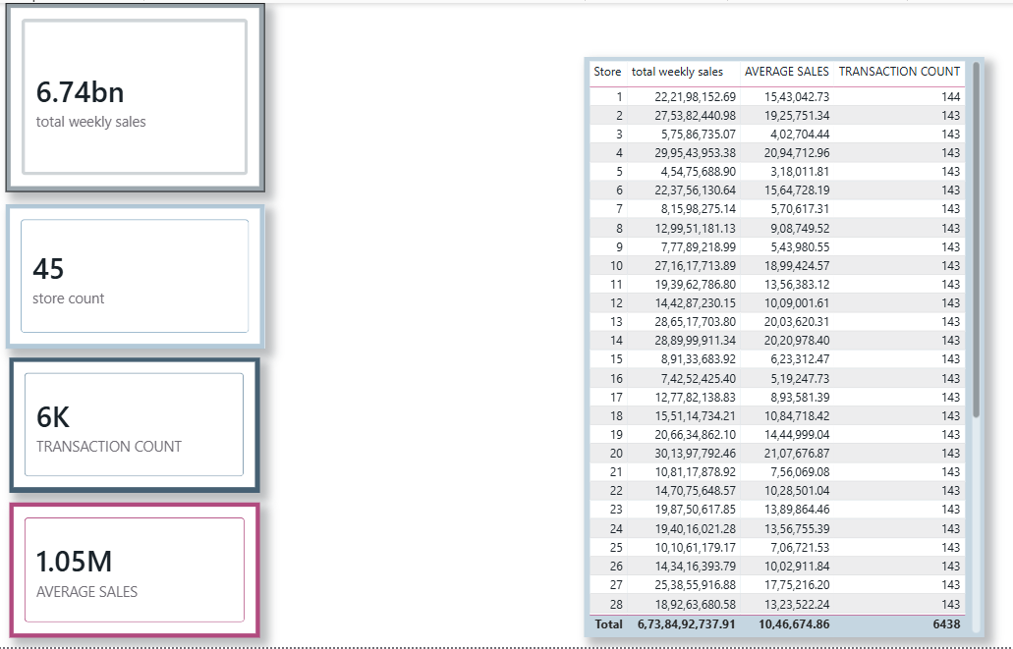
- Store Wise Total Weekly Sales
To compare stores I used a clustered column chart with Store on the axis and total weekly sales as the value. It shows at a glance which stores sell the most and which sell the least.
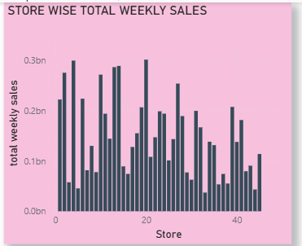
- Average Sales Trend Over Time
A line chart with the Date hierarchy (Year, Quarter, Month, Day) on the axis and average sales as the value was used to see how sales moved over time. The hierarchy makes it possible to drill from year level down to individual days.
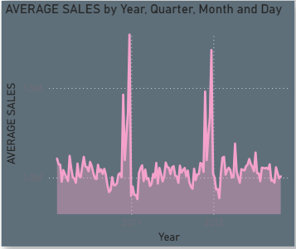
- Average Sales by Store
A clustered bar chart with Store as the category and average sales as the value was created. It helps to judge stores by their typical weekly performance and not only by their overall total.
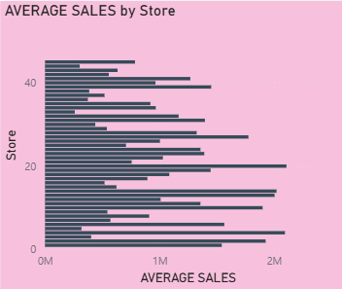
- Total Weekly Sales Trend (Area Chart)
An area chart based on the Date hierarchy and total weekly sales shows how the combined sales of all stores changed across the period. The filled area makes rises and drops easy to notice.
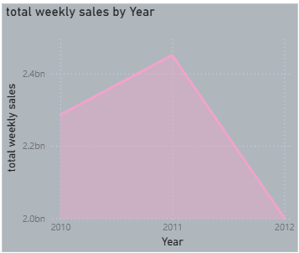
- Store Ranking Over Time (Ribbon Chart)
The ribbon chart uses Store as the category, total weekly sales as the value and the Date hierarchy on the axis. It reveals how the position of each store in the sales ranking shifted from one period to the next.
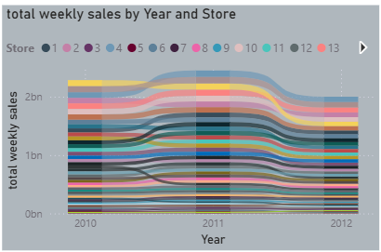
- Fuel Price vs Weekly Sales
A scatter chart with Fuel_Price and total weekly sales was added to test whether petrol prices are related to sales. A scatter plot is the natural choice for looking at two numeric variables together.
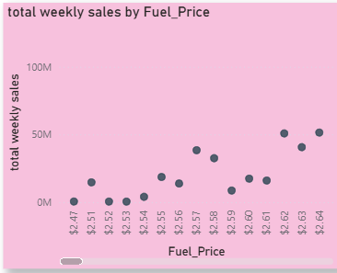
- Holiday vs Non-Holiday
A donut chart with Holiday_Flag as the legend and total weekly sales as the value compares the share of sales that falls into each holiday category.
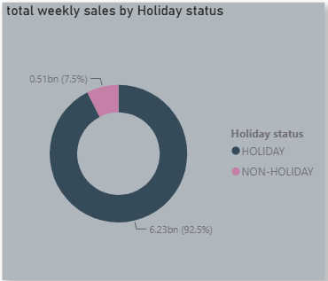
- Slicers and Interactivity
Finally, three slicers were placed on the dashboard page:
- Store (dropdown): choose one or more stores to analyse.
- Date (between): select a date range using the slider.
- Holiday Flag: filter the report by holiday or non-holiday records.
Because every visual and card is connected, changing a slicer updates the entire page instantly. This lets the same dataset be explored from many angles. Together these components take the report from a simple summary to a fuller analysis of stores, time trends, fuel prices and holiday effects.
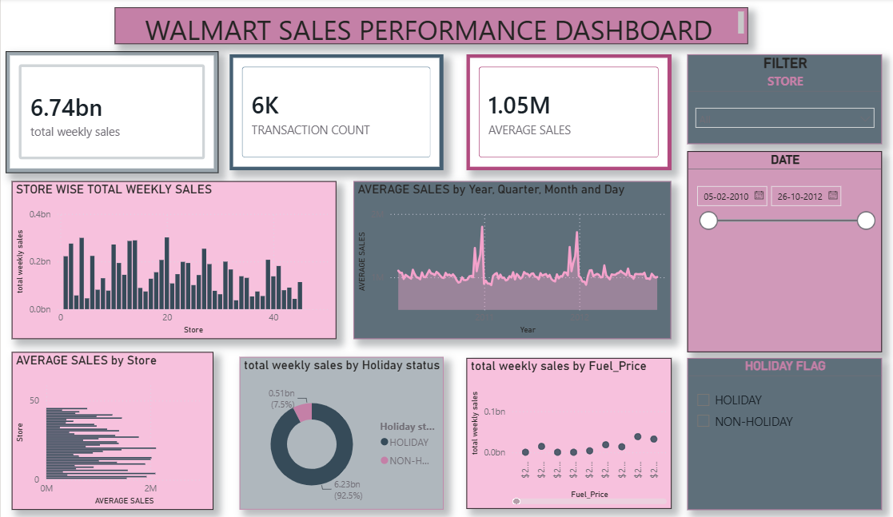
7. Key Findings
- The model contains 6,438 weekly records across 45 stores, giving a wide view of Walmart’s sales.
- Total sales come to about $6.74 billion, and the average weekly sales per store are about $1.047 million.
- Store 20 has the highest total sales at roughly $301.4 million, followed closely by Store 4 (about $299.5 million).
- Store 33 has the lowest total sales at roughly $37.2 million, which shows how large the gap between stores is.
- The largest single weekly sale in the data is about $3.82 million.
- Average sales spike sharply around late-November and December in both 2010 and 2011, which points to festive-season shopping. Late-December weeks are the highest, with 24 Dec 2010 averaging about $1.80 million per store.
- Fuel prices ranged from $2.47 to $4.47, and the correlation between fuel price and weekly sales is almost zero (about 0.01), so there is no meaningful relationship.
- Sales per year: about $2.29 bn in 2010, $2.45 bn in 2011 and $2.00 bn in 2012. The 2012 figure is lower because the data ends in October 2012.
Conclusion
This project showed me how Power BI can convert raw sales data into an interactive report that is simple to read. I built KPI cards, a table, several chart types and slicers to study Walmart’s weekly sales from different angles.
The dashboard helped me understand store-wise performance, average sales, time trends, fuel price behaviour and changes in store rankings. I also learned that visualising data makes patterns and comparisons much quicker to see than scanning raw rows.
Overall, the project gave me hands-on practice in cleaning data, writing DAX measures, choosing suitable visuals and linking them with slicers, and it showed me how a dashboard can help a manager make sense of large amounts of data.

